Will we lose our Greenbelt?
Following the public examination hearing sessions which took place over 3 stages concluding on 18th January 2017, the Government Inspector confirmed that the Council should consult on proposed modifications to both the Local and City Centre Plans. Proposed modifications were presented to Cabinet and Council on 7 and 14 March 2017 respectively.

The statutory period of consultation ran from 15th March 2017 until 28th April 2017. A series of drop in sessions were held. The session for residents of Eastern Green was held on Monday 27th March in The Eastern Green Social Club.

The AGRA committee attended the consultation meeting and also wrote to The Government Inspector regarding proposed development of Green Belt Land in The Meriden Gap. The letter is available to view on the AGRA website. www.allesleygreenresidentsassociation.co.uk
Following this consultation process the proposed modifications and all received responses will be sent to the Inspector at end May for her final consideration. Then, if the Inspector is satisfied that the proposed changes overcome all outstanding issues of soundness she will issue her final report. If issues remain outstanding then the Inspector may call additional hearing sessions or seek written clarification.

We will also be contacting our new West Midlands Mayor, Andy Street to ask that he delivers on his promise to protect the Greenbelt. See Party in the Park on next page.

We are privileged to live so close to the greenbelt and to benefit from seeing the wildlife that visits our gardens. In recent weeks residents have reported that Muntjac Deer and Pheasants have been seen in addition to our usual garden visitors. The migratory Swallow has returned and have been seen building nests. What have you seen?
Next Meeting of Residents’
You are invited to attend the next meeting of Allesley Green Residents’ Association on Wednesday 14th June 2017. The meeting will be at Park Hill School, commencing at 7.00pm. Topics for discussion will include;
Local Plan Examination Update - We will provide an update on the status of the examination process.
Juniper Park -Work on Phase 1 is completed. What improvements would you wish for Phase 2 if we can obtain funding?
Councillors Report – Including, why are our Pavements being dug up again? What is the Council doing to ensure that the work is being completed to deliver a good quality result?
AGRA Membership Status Report
Wills and Powers of Attorney- Be Prepared - A presentation by Peter Heath of AGRA.
Party in the Park
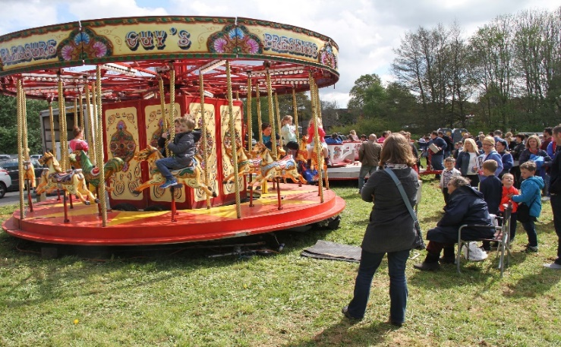
The 4th Party in the Park, a joint venture between Allesley Green Residents’ Association and St Andrew’s Church Eastern Green took place on Monday 1st May 2017. The event was enabled through funding from various charities who supported our aim to build community spirit, ensuring children, young people and adults mix in a relaxed social setting where everyone could enjoy themselves.
The charities that enabled this event were;
- West Midlands Police and Crime Commissioner – Active Citizen Fund
- Heart of England Community Foundation
- Coventry General Charities
In addition, donations were received from local businesses to provide prizes for a raffle to also help fund the event. Our thanks to;
Windmill Village Hotel, West Midlands Golf, Le Loren Hair & Beauty, Ron Barker Butcher, Wasps Rugby and Berryfields Farm Shop.
We provided activities and entertainment for every age group and believe that the day was a success. In addition to local residents the event was attended by Andy Street who has since been elected as the West Midlands Mayor. Andy pledged his support to fight for the Protection of Green Belt Land.
Geoffrey Robinson, our local MP also paid a surprise visit to the event. AGRA had previously requested his support in fighting the Local Plan's green belt proposals during the formal consultation process, however this support was not forthcoming. Interestingly, in his election campaign literature he is campaigning against building on greenbelt land.

Live Entertainment was provided by Coventry Festival Band, Soulful Gospel Choir, En Pointe Dance Group, Speak Brother and the Ukaholics, a Ukulele Band.

Fun for all the Family was provided with Bouncy Castles, Fairground Rides, Donkey Rides, Thai Food, Hot Drinks, Stalls & Games, Burgers, Hot Dogs and Local Interest Groups. Our local police and fire service attended and allowed their vehicles to be inspected.

The event was enabled by the number of residents who volunteered to set up, run stalls and help take everything down at the end. Our thanks to one and all.

We would welcome feedback from those who attended the event in order that we consider new ideas for next year.

Quiz Night / Fish Supper
We are planning to hold a Quiz Evening on Friday 13th October 2017. The venue will be the Massey Ferguson Social Club on Broad Lane. So, put the date in your diaries
You are welcome to invite family, friends or ideally neighbours’ to make up teams of no more than six. Teams of six will also be created on the evening for individuals or couples who wish to attend.
Become an AGRA member
Membership registers that you do wish to develop our community and ensures that you receive information regarding issues affecting residents as they arise. This is primarily via email. Regular meetings with guest speakers also ensure you are kept informed.
The membership fee of £5 for the year, April 2017 to March 2018, funds the running of the Association including printing and venue hire and running of our website.
Please join via our website or by contacting any of the AGRA Committee.
Our Mission
We live in a beautiful part of the city with the lowest crime figures in the area and we want to keep it that way, so let’s be good neighbours’ by looking out for and talking to each other. Active residents can ensure that we maintain and improve our environment and develop our community spirit.

