St Andrew’s Church
Responding to a
Safeguarding Concern or Allegation
There are many situations whereby a member of the church may have concerns, or be made aware of concerns, regarding a child, young person and adult. For example:
- A child, young person or adult discloses abuse;
- Someone discloses concern for a child, young person or adult;
- Someone notices signs of potential abuse of a child, young person or adult;
- A child, young person or adult makes a disclosure about their own behaviour towards another child, young person or adult;
- Someone witnesses concerning behaviour during a church activity or during a home visit.
The concern or allegation might relate to someone at church or to someone elsewhere (e.g. at home, work or school). It might be a current situation, or something that happened in the past.
This procedure must be followed by all church officers and it is strongly recommended for all other church members.
This procedure will be distributed to everyone who undertakes safeguarding training.
It will be distributed by the PSO with the help of the administrator. New church officers will receive a copy by the PSO.
Should a concern arise, during a church activity it must be bought to the attention of the leader who will then notify the PSO. If unavailable, then contact the vicar. Should there be a risk of imminent harm, the police can be contacted. The diocesan safeguarding team also have a number (see back of document), in which they can be contacted, and they need to be informed of any safeguarding concern or allegation within 24 hours.

Listen carefully
Whenever anyone reports that they are suffering or have suffered significant harm through abuse or neglect, or have caused or are causing harm to others, the initial response should be limited to listening carefully. If someone makes a disclosure this might be the only time they will tell someone about what is happening.
Please…
- Listen.
- Take what is said seriously.
- Remain calm.
- Take into account the person’s age and level of understanding.
- Offer reassurance that disclosing is the right thing to do.
- Explain that information will need to be shared with the appropriate people.
- Only use open questions.
- Establish only as much information as is needed to be able to report what is believed to have happened, when and where.
- At the end, check that you have understood everything correctly.
- Check out what the person hopes to result from the disclosure.
- Tell the child or adult what you are going to do next.
However…
- Do NOT make promises that cannot be kept (e.g. that you won’t share the information).
- Do NOT make assumptions or offer alternative explanations.
- Do NOT investigate.
- Do NOT contact the person about whom allegations have been made.
- Do NOT carry out a physical or medical examination.
- Do NOT share with anyone other than those persons mentioned on the previous page.
Make a record…
- Make some very brief notes at the time, if appropriate, and write them up in detail as soon as possible.
- Do not destroy your original notes in case they are required by the Diocesan Safeguarding Adviser or the statutory authorities.
- Record the date, time, place and how the person appeared to you. If possible, try to record the actual words used, including any swear words or slang.
- Record facts and observable things, not your interpretations or assumptions.
- Don’t speculate or jump to conclusions.
Report promptly…
Never do nothing. Always follow the procedure below.

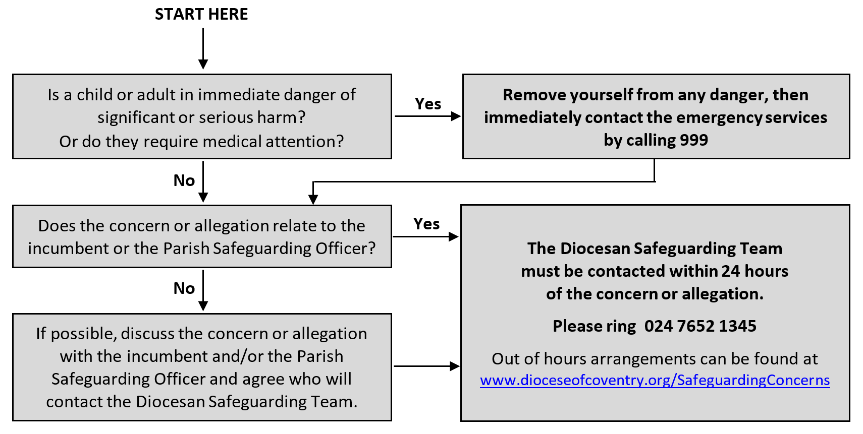

A church officer is anyone appointed/elected by or on behalf of the Church to a post or role, whether they are ordained or lay, paid or unpaid.
Open questions begin with words like: who, what, when, where and how. They cannot be answered with a ‘yes’ or ‘no’.

